**Linux Assignment**

1. Create a new directory called "practice" in your home directory.
2. Text

   Description automatically generatedInside the "practice" directory, create a new file called "file1.txt" and add some text to it.
3. Copy "file1.txt" to a new file called "file2.txt" in the same directory.
4. Text

   Description automatically generatedMove "file2.txt" to a new directory called "backup" that is located inside the "practice" directory.

 5.Create a new directory called "scripts" inside the "practice" directory.

1. Create a new file called "myscript.sh" inside the "scripts" directory.
2. Add the following code to "myscript.sh":

#!/bin/bash

1. echo "Hello World!"



1. Make "myscript.sh" executable using the command "chmod +x myscript.sh".
2. Run "myscript.sh" using the command "./myscript.sh".
3. 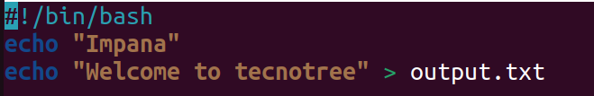Add a line to "myscript.sh" that creates a new file called "output.txt" in the same directory and writes the output of the "echo" command to it.
4. Text

   Description automatically generatedRun "myscript.sh" again and verify that "output.txt" has been created and contains the expected output.
5. Create a new user account called "testuser".

1. Switch to the "test user" account using the command "su testuser".

1. Verify that you are now logged in as "testuser" using the command "whoami".

1. Switch back to your original user account using the command "exit".

